API Testing

Using Postman
Postman is the most widely used tool for API testing. It allows us to build requests, send them, inspect responses, write test scripts, and organize everything into collections

Steps Included:
1- Creating a new request
2- Setting the method and URL
I chose GET from the dropdown method, then paste a URL (a public endpoint)
3- Sending the request
When clicking the blue Send button. In the bottom panel, we see: the response body (JSON), the status code, the response time, and the response headers.
4- Trying all four HTTP methods

Method | Main Goal | URL | Expected status code
GET | Return or retrieve data from server | https://api.restful-api.dev/objects/7 | 200 OK
POST | Create or send data to server | https://api.restful-api.dev/objects | 200 OK
PUT | Update existing data | https://api.restful-api.dev/objects/{id} | 200 OK
DELETE | Delete data with specific id | https://api.restful-api.dev/objects/{id} | 200 OK

Get Method
1- Get Request
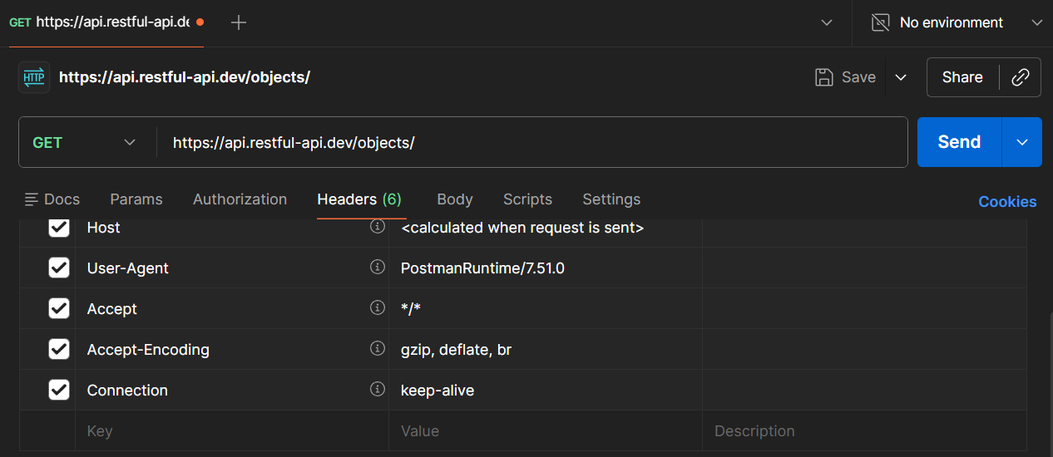

2- Response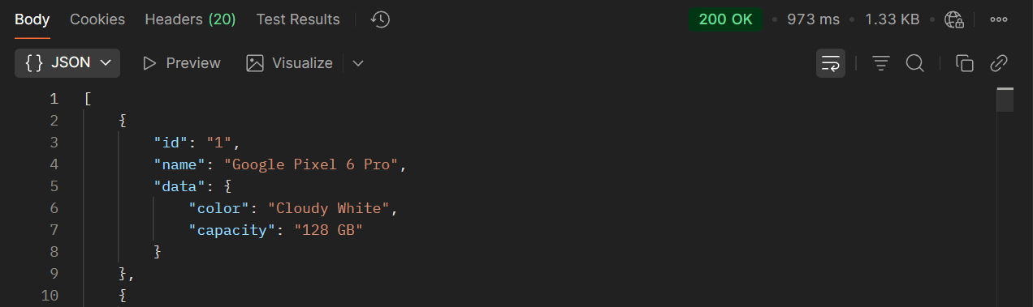

Post Method
1- Post Request
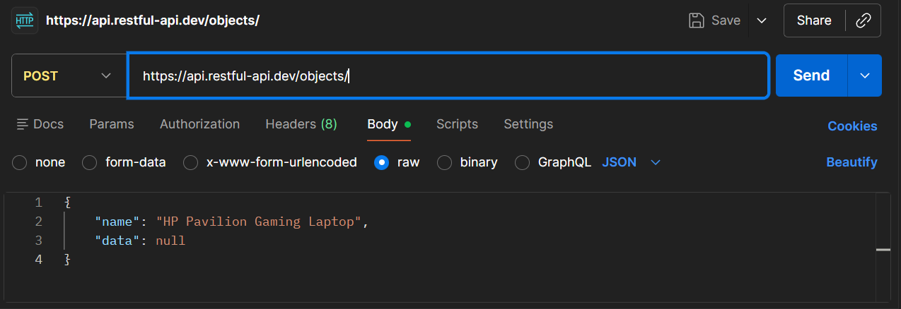

2- Response
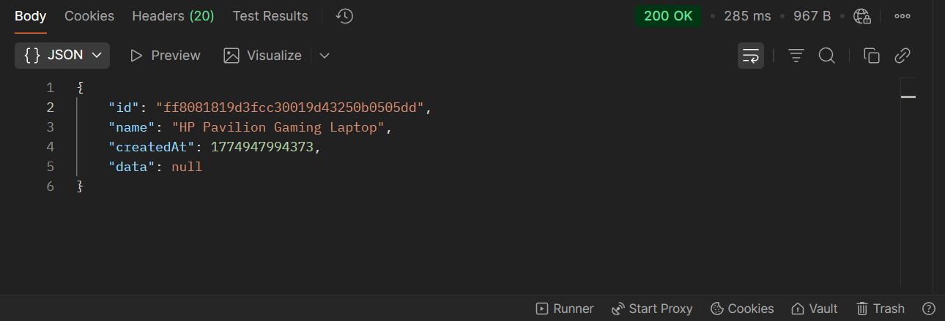

Put Method
1- Put Request
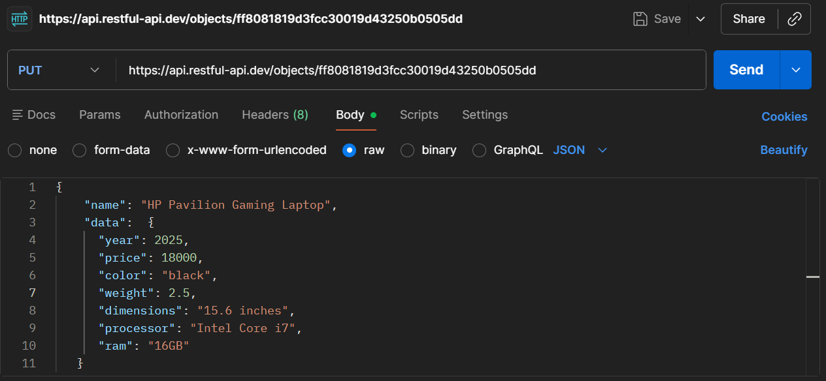

2- Response
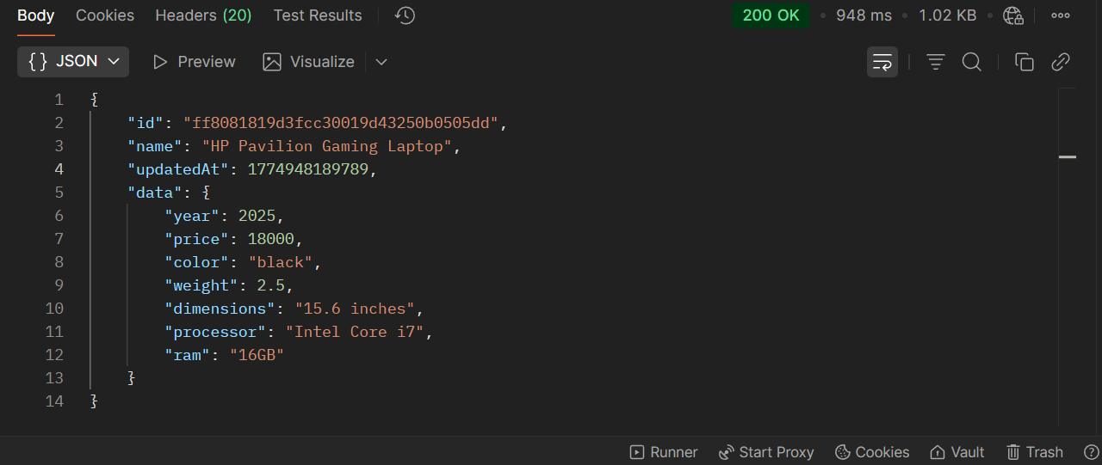
Delete
1- Request
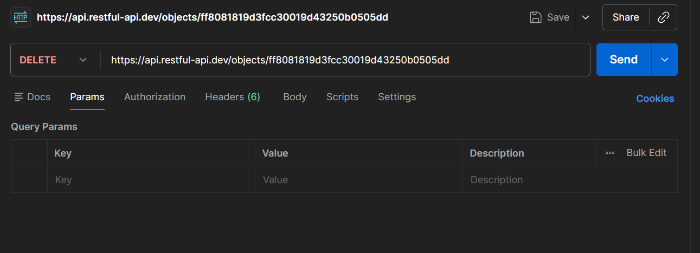

2- Response
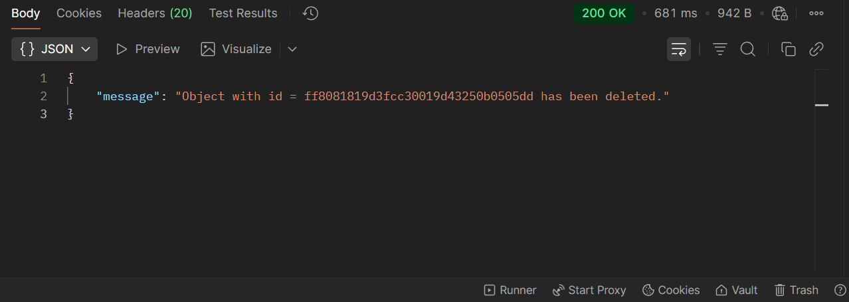

Testing cases:
1- checking for status code validation, error message meaningfulness, and edge cases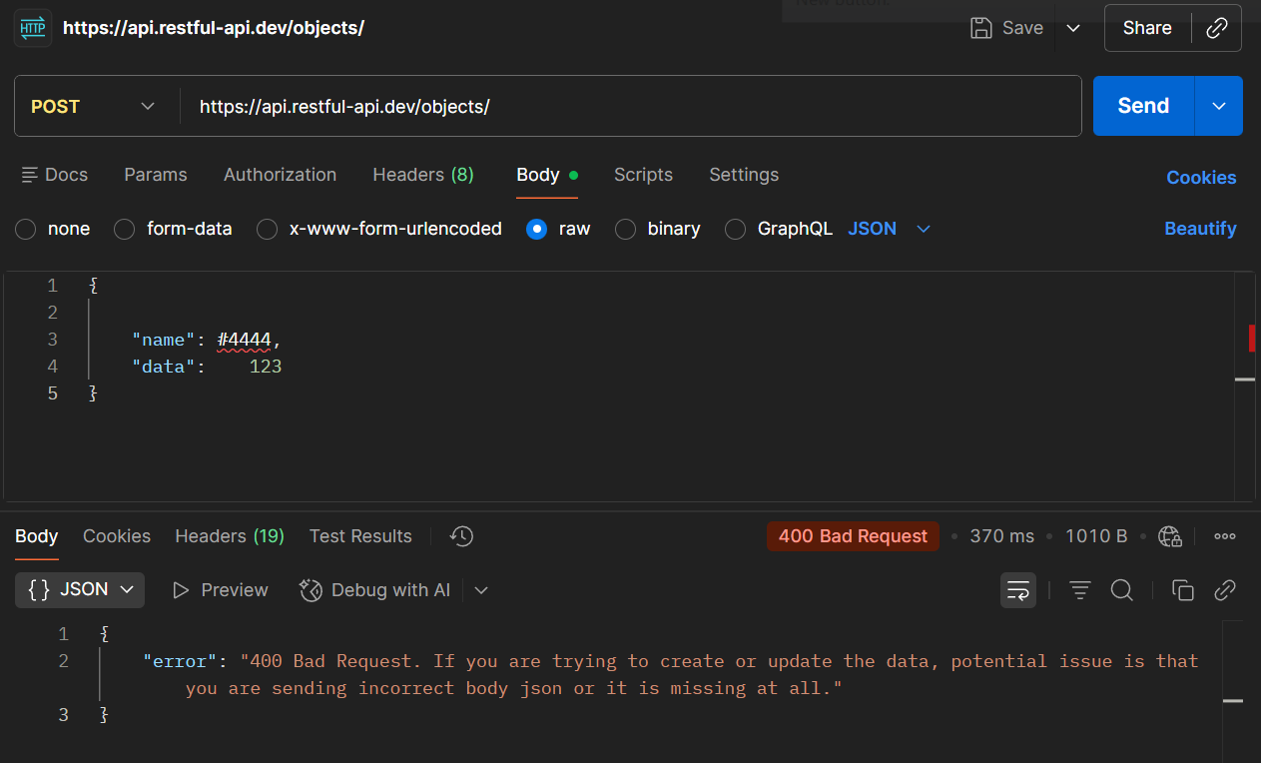

2- checking for non-existent value
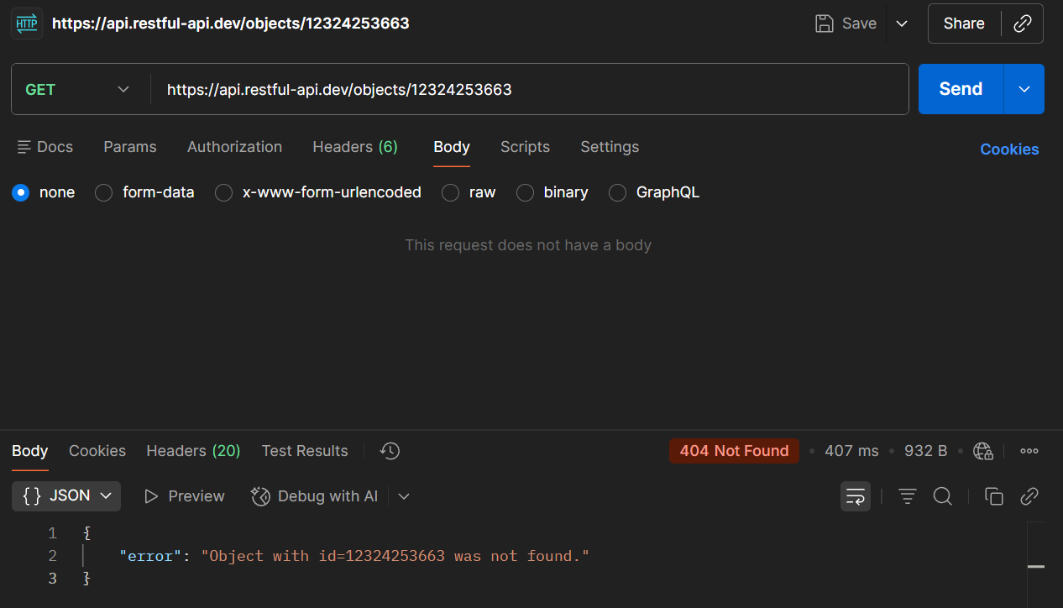

Validating API Reponses
As API testers, we make sure that the API works correctly, reliably, and safely via:
- Checking for status code
- Checking for correct response data
- Checking for response body
- checking for response time
- checking for error message meaningfulness
- checking for edge cases handling
- making sure that no sensitive data appears in the response

